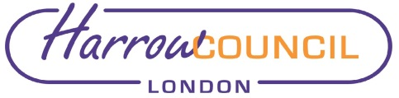

REPORT FOR: | HEALTH AND WELLBEING BOARD
Date of Meeting: | 2 May 2019
Subject: | Commissioning Capabilities Course
Responsible Officer: | Javina Sehgal, Managing Director  NHS Harrow CCG  Paul Hewitt, Corporate Director People Services, Harrow Council
Public: | Yes
Wards affected: | All
Enclosures: | Annexe A: Commissioning Capability Programme Terms of Reference

Section 1 – Summary and Recommendations

This report provides an update for the committee on the Commissioning Capability Programme (CCP) in progress across Harrow which involves key stakeholders across the Borough.

Recommendations:

The board note the report

FOR INFORMATION

Section 2 – Report

Introduction and context
To achieve the objectives set out in the NHS Long Term Plan, the NHS in England requires commissioning capabilities that can deliver better care and health at lower cost. While the strategic focus of NHS England remains on developing a programme to help organisations migrate towards new models of care, feedback from the system has highlighted a ‘here and now’ need to build the longer-term capability of senior commissioners in the health and care system.

Accordingly, NHS England is investing in a major capability building programme for senior commissioning leadership over the next 15 months in order to help these leaders develop the skills they need to tackle today’s and tomorrow’s challenges across the health system.

The Commissioning Capability Programme
The Optum Alliance was selected through a competitive tender process as the preferred supplier. The Optum Alliance is formed of Optum Health Solutions and PricewaterhouseCoopers.

The CCP is a 12 week programme which aims to develop the leadership capability of senior commissioning leadership teams across five learning streams:

- Building a sustainable strategy;
- Financial planning and recovery;
- Governance;
- Executing and implementation; and
- Managing and influencing.

The programme has a blended approach to learning and uses a range of learning interventions to improve the capability among executives, namely:

- Facilitated workshops: Workshops are developed for each CCG and are facilitated by subject matter experts. Workshops bring new content and ideas from an international evidence base which is translated to the local context and tailored to provide insight for each system and executive team.

- Coaching: The Optum Alliance has fielded its most senior partners, directors and doctors to act as programme coaches. All coaches are experienced leaders in complex business systems. Coaches help participants work through complex problems and build their own capability. In addition to collective objectives, participants will set individual objectives with their coaches and agree to a personal development plan (PDP).

- Materials for self-led learning: Through extensive design work the Optum Alliance has identified learning materials. Bespoke learning materials are selected for each CCG on a weekly basis. Content is live and responsive to the needs of the CCGs.

Programme participants and coaches
Seven individuals have been identified below to take part in Module 1:

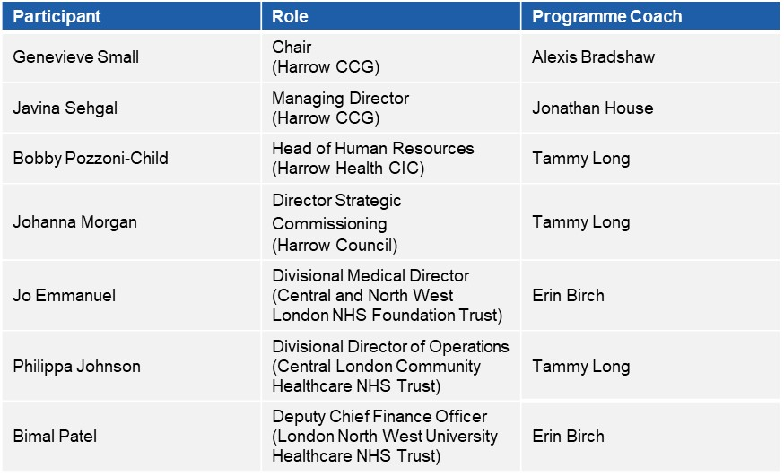

Areas of focus identified within the programme:
As a result of the initial scoping phase, which included meetings with participants identified at this point and a full review of relevant documents, the delivery team have tailored the CCP to the needs of the Harrow CCP.

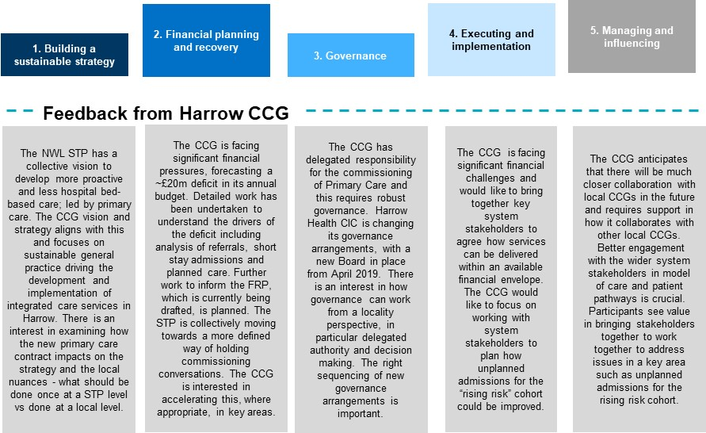

Why Harrow CCG has been invited to take part in the CCP
The CCG has been invited to take part in the CCP because of the financial challenges it is currently facing. The programme will provide an excellent opportunity for key system stakeholders to come together and develop a strategy that is fit for the future. The programme will also support the organisation to execute their financial recovery plan and closely align itself with the external system partners. The Terms of Reference for the Programme are at Annexe A.

Evidencing success
Two frameworks which are helpful to use in terms of measuring success in commissioning capability is the CCG Improvement and Assessment Framework (IAF), and the new planning guidance, ‘Refreshing NHS Plans for 2018/19’. Each of the CCG outcomes has been described in terms of inputs (the support that will be provided), outputs (the work that will be produced together through the programme), and how this will lead to a form of improvement. Where relevant, connections are also made to the planning guidance.

Expected wider benefits
Achievement of these improvements in capability will help equip the leaders of the Harrow CCG to make rapid strides towards transforming health and care in this health economy. It will help accelerate the reform agenda set out in the STP and make this real for the local system. Commissioners working together will be able to make a long planned transition to an integrated care model including enhanced community based services which will provide improved care, closer to home and reduces costs.

Sustaining and embedding improvement
Participants will commit to regular self-assessments of the progress they are making to individual and organisational development goals:

- 6 weeks – check in to make sure learning objectives are being met and CCP is on track to support achievement of above objectives
- 12 weeks - on completion of the 12 week programme, participants will agree and commit to forward capability development plan for the next 6-12 month period
- 3, 6 and 9 months – the CCP team will connect with participants quarterly to help review progress and maintain momentum.

Progress from the focus groups/workshops held to date:

- Workshop 1 - High Performing Teams and Strategy (21st March 2019)

Recommendations:
- Expand the population cohort for the ICP to over 65 years old.
- All organisations will collect and share activity and cost data for the over 65 years old cohort to support the system integration. This data would not be used adversely.
- Review revise and update timelines, milestones and the associated work plan across 3, 6 and 12 months recognising the required pace and scale of change.
- All partners / system to recognise that the ICP / ICS is the bedrock and fundamental principle for financial recovery.

- Workshop 2 – Governance (25th March 2019)

Objective:
- We want to “make governance real” and for us to be able to manage tensions that can manifest when there are differences in what is best for the STP / place vs what is best for individual organisations.
- We want to have effective governance in place that allows devolved decision making (at pace) based on better relationships and enhanced trust.
- For us to better understand STP, place based and organisational governance processes, particularly sign-off and decision making processes.
- We want to be able to bring our organisations with us
- We want to understand how to make governance proactive and for it to serve the needs of the patient.

Outcomes:
- It was agreed that it is key for Harrow to have a “compelling core shared purpose” and “capability and capacity to deliver”
- It was agreed that there was a need for strong clinical, practitioner and professional leadership. Replicating the STP governance structure would give the opportunity for clinicians and care professionals to inform the strategy and operational plans

To note, Workshop 3 – Finance was on Monday 15th April 2019.

Ward Councillors’ comments

This affects all Wards.

Financial Implications/Comments

At present there are no additional financial implications associated with the Programme. The intention being that the improved working relationships as a result of this programme will facilitate the delivery of Integrated Care in Harrow and more effective provision.

Legal Implications/Comments

The purpose of the Health and Wellbeing board is defined under part 3A of the Constitution to include the promotion of integration and partnership across areas, including through promoting joined up commissioning plans across NHS, social care and public health, and to support joint commissioning and pooled arrangements, where all parties agree this makes sense

At present there are no legal implications. However, as the integration agenda processes there will need to be consideration of legal requirements of the local authority and health services.

Risk Management Implications

There are currently no risk implications.

Equalities implications / Public Sector Equality Duty

Was an Equality Impact Assessment carried out? No

EqIAs will be undertaken when appropriate to support specific programmes and project.

Council Priorities

The CCP contributes to the Council’s priorities of supporting those most in need and protecting vital public services.

Section 3 - Statutory Officer Clearance
(Council and Joint Reports

 |  |  | on behalf of the
Name: Sharon Daniels | X |  | Chief Financial Officer
Date: 24 April 2019

Name: Paul Hewitt | X |  | Corporate Director
Date: 24 April 2019

Ward Councillors notified: | NO

Section 4 - Contact Details and Background Papers

Contact: Javina Sehgal, Managing Director, Harrow CCG, 020 8966 1147

Background Papers: None

